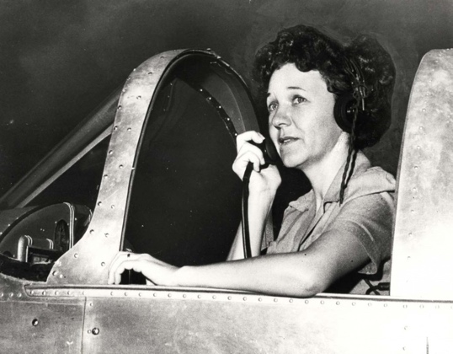
Marguerite Gambo Wood Flight Training Scholarship
Awarded by the Aloha Chapter Ninety-Nines
2024 Scholarship Information & Application Form

The Aloha Chapter Ninety-Nines Scholarship Committee invites qualified women pilots to apply for scholarship assistance to support their flight training. In addition to fostering camaraderie, sponsoring, and organizing flight events, serving as an information resource, and carrying out flight-related community service, the Ninety-Nines organization has provided networking and financial support to further the aspirations of women aiming to become professional pilots.

The Aloha Chapter Scholarship Committee administers The Marguerite Gambo Wood Scholarship which is funded from the Marguerite Gambo Wood Trust as well as from other private individuals who desire to support flight training for women through the Aloha Chapter. Scholarship applicants are asked to participate in Aloha Chapter activities of The Ninety-Nines International organization to become acquainted with the mission and to become connected with other women pilots who have received scholarships.

The following requirements apply to be eligible for the 2024 Marguerite Gambo Wood Flight Training Scholarship
- Active membership with the International Ninety-nines, as of January 1st, 2024
- Active membership with the Ninety-nines Aloha Chapter or Maui Chapter, as of January 1st, 2024

To join The Ninety-nines International visit https://www.ninety-nines.org/membership.htm (Please be sure to designate the Aloha Chapter or Maui Chapter when you register. If you are unable to register, please contact us.)

To join the Aloha or Maui Chapters, contact them directly alohachapter99s@gmail.com, mauichapter99s@gmail.com

After completing the scholarship application, page 2 and 3 of this document, scan all required documents into one PDF and submit via email to Scholarship Chairman Tanya Rames. ramestanya@gmail.com

Application is due February 1st, 2024, and will be awarded March 1st, 2024. Late applications will not be accepted.

Materials REQUIRED:
- Application Form
- Resume
- Personal Essay: Please submit a one-page personal essay about yourself including the following:
  - Your history and goals in aviation
  - Any past volunteer experience in or out of the aviation community
  - How you plan to contribute to the aviation community or the Ninety-nines in the future
  - What specific certificate or rating this scholarship will help you finance, what the hourly cost of the aircraft to be flown is and how many hours are required
  - How you have financed your training so far
  - Any financial need if applicable
- Copy of Pilot Certificate
- Copy of Medical Certificate
- Two letters of recommendation addressed to ‘The Aloha Chapter Scholarship Committee’. Contact information must be included to enable references to be checked.

The specific award amount of this year’s scholarship will be determined after the scholarship committee has reviewed all qualified applications and funding. Scholarship recipients will have until February 1st, 2025 to use their funds.

2024 Aloha Chapter Scholarship Board – Tanya Rames, Cynthia Fiaui, Suzi Davis and Annie Domko
Aloha Chapter
2024 Marguerite Gambo Wood Flight Training Scholarship

Applicant Information
Full Name: |  |  |  | Birthdate:
 | Last | First | M.I.

Address:
 | Street Address | Apartment/Unit #

 | City | State | ZIP Code

Phone: |  | Email:
Most recent certificate/rating received:
Certificate number: |  | Date received:

Certificate/rating for scholarship to be used:

Total hours: |  | Hours flown in the last 6 months:

Total household income: |  | Number in household:

Ninety-nines continuous membership date: |  | Chapter:

Class of medical certificate (when received): |  | Date medical received:

Highest level of education completed: |  | Are you currently in school?

Scholarship History

List all other scholarships received in the past 12 months or currently pending: Attach additional page if needed. MANDATORY: Send updates on pending scholarships to alohachapter99s@gmail.com upon learning results through February 1st, 2023.

Scholarship/Grant Name | Amount | Purpose(Certificate or Rating) | If pending, expected notification date

Disclaimer and Signature
SCHOLARSHIP REQUIREMENTS: Resident of Hawai‘i; Aloha/Maui Chapter Member; Commitment to participating in 99s Aloha/Maui Chapter activities and the Aloha Chapter event at which scholarship recipients are announced and scholarships awarded. Winners should be present, if possible, to receive a scholarship.
AFFIDAVIT: “The information I have given on this application form and in the accompanying essay is true and correct. Incorrect information could forfeit my scholarship award. I meet the requirements for this scholarship. I will do my best to meet the scholarship requirement of participating in the chapter event at which the scholarships are awarded. In addition, I will make every effort possible to attend the 2024 events to report on my use of the scholarship and how it has contributed to my career as a pilot.”

Signature: |  | Date:

